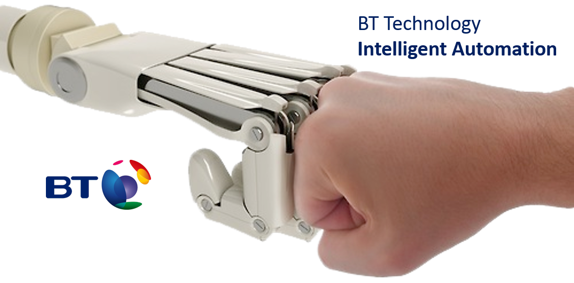

BT Technology / Intelligent Automation

QC- Administration

RPA Design Document

Version

01/03/20



# Contents Page

1 Executive Summary 5

2 Document Details 6

2.1 Document History 6

2.2 Document Approvals 6

3 Introduction to Automation 7

3.1 RPA Overview 7

3.2 Blue Prism Overview 7

3.3 Automation versus Development 7

4 Automation Design Principles 8

4.1 General Principles of Automation Design 8

4.2 General Principles of Data Handling 8

4.3 Data Usage 8

5 [Process Name] 9

5.1 Human Process Summary 9

5.2 Robotic Process Summary 9

5.3 Scope of the Automation 9

5.4 Process Volume & Profile 9

5.5 Compliance & Regulation 9

5.6 Risks & Mitigation 9

6 Operational Impact 10

6.1 Impact to Existing Processes 10

6.2 Impact to Training 10

6.3 Impact to Existing Systems 10

7 Robotic Process Detail 11

7.1 High Level Architecture 11

7.2 Triggering the Robotic Process 11

7.3 Work Item Priority 11

7.4 Robotic Flow 11

8 Process Layer 12

**8.1** Process Detail 12

9 Object Layer 13

9.1 [Name of Object] 13

10 Data Model 14

10.1 Data Structure Principles 14

10.2 Primary Data Structures 14

10.3 Data Types 14

10.4 Environment Variables 14

10.5 Data Storage 14

11 Exception Handling 15

11.1 System Exceptions 15

11.2 Business Exceptions 15

11.3 Other Handoffs 15

12 Design, Configuration & Testing 16

12.1 Design, Configuration and Testing Principles 16

12.2 Warranty Period 16

12.3 Environments 16

13 Reporting 18

13.1 Tagging 18

14 Robotic Workforce & Scheduling 19

14.1 Working and Non-Working Days 19

14.2 Robotic Workforce 19

14.3 Robotic Process Schedule 19

15 In Life Management & Support 20

15.1 Change Management 20

15.2 Support Framework 20

15.3 Reporting & Monitoring 20

16 Access Control 21

16.1 Principles of Robotic Access Control 21

16.2 Access Accountability 21

16.3 Access Management 21

17 Glossary 22

# Executive Summary

The QC administration process is all about managing the user accounts such as user account creation, deletion, roles assignments based on projects, reactivation and password reset.

The process starts when people start receiving request in email based on the request type and its been processed in by operation team and revert to respective requestor in email.

The suggested To Be process is to create a centralised SharePoint site to track all the request submitted by requestor, Also we can the store the request for audit purposes. Instead of human process now operations team just validates the request and approve it to robot which will be picked and created in QC tool based on the request type.

# Document Details

## Document History

|  |  |  |  |
| --- | --- | --- | --- |
| **Version** | **Date** | **Responsible** | **Change Summary** |
| 1.0 | 1/02/2020 | Iopex | Initial Draft |
|  |  |  |  |

## Document Approvals

|  |  |  |  |
| --- | --- | --- | --- |
| **Approver** | **Version Approved** | **Date Approved** | **Approval Type** |
|  |  |  |  |
|  |  |  |  |

# Introduction to Automation

## RPA Overview

Robotic Process Automation (RPA) uses technology to replicate human processing of administrative tasks in a manner like that of how robotic mechanical automation replicates physical processes. RPA is used to realise efficiencies by replacing, in whole or in part, human processing with robotic processing. This achieves benefits of cost reduction, error reduction, compliance increase and empowering operational terms to focus their energies on tasks that require human capabilities such as understanding customers, empathy and decision making.

## Blue Prism Overview

Blue Prism is BT’s chosen application for RPA. Blue Prism interacts with systems at the interface layer. This can include the visual user interface, or the interface components exposed to the operating system and accessible to the user interface. Blue Prism access interface components through the functions and methods exposed by those components. Interface interaction is not typically achieved through so called ‘screen-scraping’ though Blue Prism has the capability to interact with an interface by searching for graphical elements on the screen. Rather, Blue Prism interacts with the interface through named components either in Windows applications or through HTML elements in browser-based systems.

Configuration of a Blue Prism automation involves the creation of two layers. The Object layer controls interactions with the systems used in the automation. The Process layer contains the logic, sometimes called ‘business logic’, that determines the actions of the automation. The process layer does not interact directly with applications. Rather, the process layer submits requests to the object layer for interactions with systems.

This layered approach ensures that process logic is independent of the systems involved in the process. This enables efficient in-life management of automations and changes to either processes or systems by restricting changes to the layer at which the change impacts.

## Automation versus Development

In some situations, it is preferable to modify systems to accommodate business requirements or process changes. This approach is referred to as ‘development’ or ‘traditional development’. Where development is not preferable, perhaps due to time or cost factors, automation can be used to deliver business requirements without the need for development to the systems used by a business process. Automation may also be considered as a tactical solution in some situations, while development takes place.

Automation does not eliminate the need for ongoing system development and evolution. Rather, automation is another option to meet business requirements. It should be considered complimentary to development not a replacement for it.

# Automation Design Principles

## General Principles of Automation Design

* Automations will be configured in accordance with the principles of GDPR (General Data Protection Regulation), PCI-DSS (Payment Card Industry Data Security Standard) and DPA (Data Protection Act).
* Automations are configured in accordance with Blue Prism best practice.
* Automations are built to minimise the use of server and desktop resources.
* Automations will not be applied to out of the box products where it drives a customisation of a core product or impacts any SaaS or third-party service or operational level agreements.
* Automations will use existing exposed services.
* Automations will not be configured such that both the solution and the process are held within them to ensure that the process and knowledge of that process are not lost in the event of failure of an automation
* Surface automation (also known as scene composition or screen scraping) will be used as a technology of last resort when no other connectivity option is available.
* Automations will launch screens or systems only when those screens or systems are not already active. Existing sessions will be accessed where available.
* Automations will be configured to include alerts that warn the automation team of failure of a process.
* Automations will be configured to include the capture of data for performance analysis.

## General Principles of Data Handling

Automations use data only while processing transactions. They will capture data from accessed systems as part of that transactional processing and write values to internal variables in memory. Data values will also be manipulated in memory and written back to accessed systems, as required by the process being automated. Automations do not write data to a separate database or other storage medium beyond those already used as part of the human execution of the process. Automations do not, therefore, introduce any additional data storage.

Automations create local logs of their processing activities including details of each step in the automated flow. These logs contain data for troubleshooting purposes that can identify which transaction has been completed and, should a failure occur, the point at which the failure happened. Automations are built so that individual identifying data (such as customer details for example) is not captured in the logs.

## Data Usage

Beyond logging as described above, automations do not retain any data once execution of the process has completed. All internal memory variables are cleared at the conclusion of the transaction and reset to default or blank values.

While executing a process, automations do not use data for any purposes other than those required by the process, replicating the human use of that data for the same process.

# QC - Administrations

## Human Process Summary

The Human process commences when the requestor raises a request for QC tools in email. Based on the request type human process the request in QC tool and revert in same email thread.

### Out Look

* Request will be received through email

### Login to QC Adminstration

* Click Administration

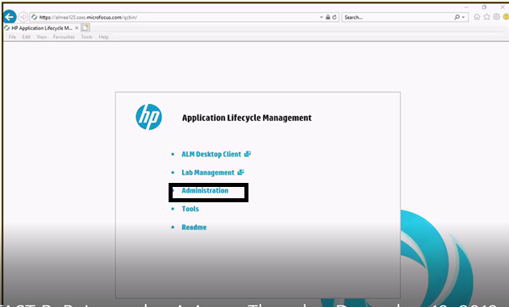

* Enter the username and password
* Click Login

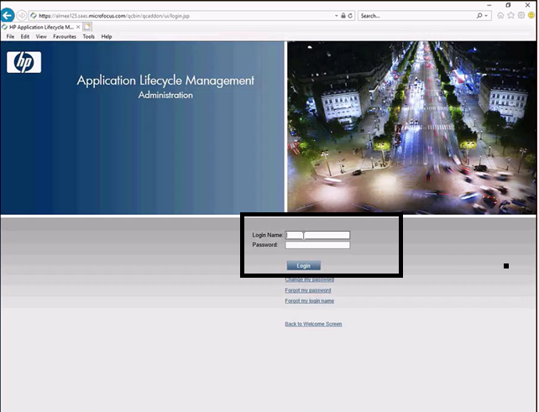

### Creating New user to access QC Administration

* Click User management

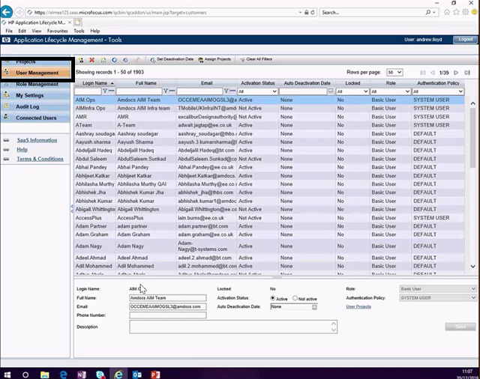

* Click ADD User
* Enter the Login Name and Email ID and the Domain should be authorized
* Create a password
* Click Send Notification
* Click OK button

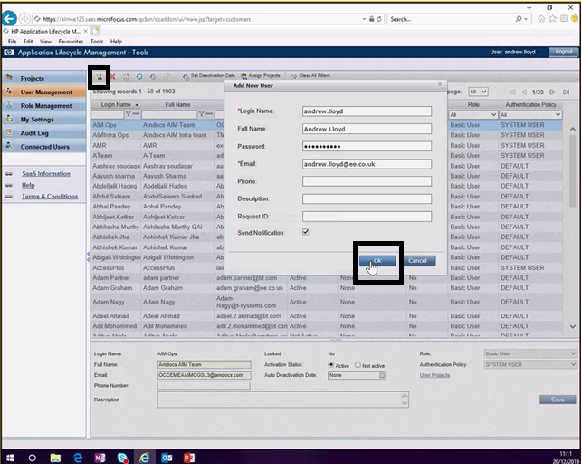

* Assign project for user new user
* Highlight the new user and the click Assign Projects

* Domain Name, Project Name must select
* Grant and remove roles for the selected users in the selected project by checking and unchecking the relevant checkboxes.
* Click Next

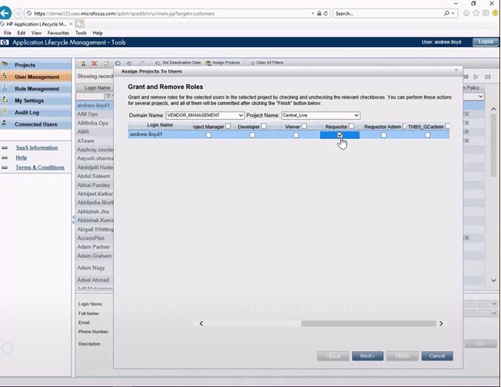

* Summary Page

* After clicking finish button, status will be displayed as operation completed

* Mannualy SME will send the confirmation mail to the New users with their username and password

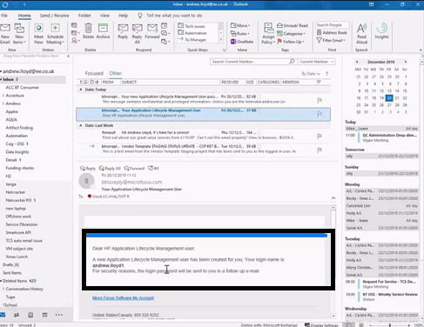

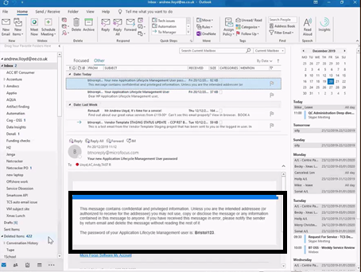

### Reactivaing the user access



* Login Name
* Email Address

If the users have not logged in for 60 days or above, when he/she tries to login will through an error message from QC

* Just put the login name and click the activation status to active and click save
* Send the email notification to the person to login into QC

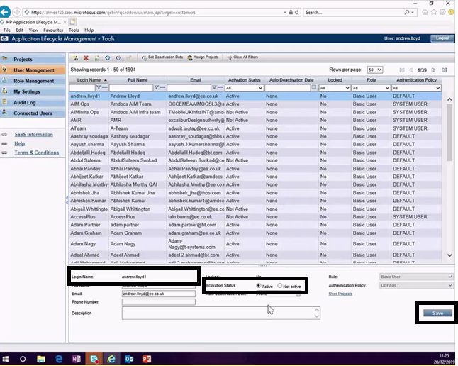

### Additional Access to QC

### Click the user and Assign project

* Domain Name, Project Name must select
* Grant and remove roles for the selected users in the selected project by checking and unchecking the relevant checkboxes.
* Click Next
* Summary page and click finish
* Send the notification email to the user that Additional access has been added in QC

### Unlocking the account

* Once the SME receive the blocked username through email
* Click the unlock user icon to activate the locked account and click OK

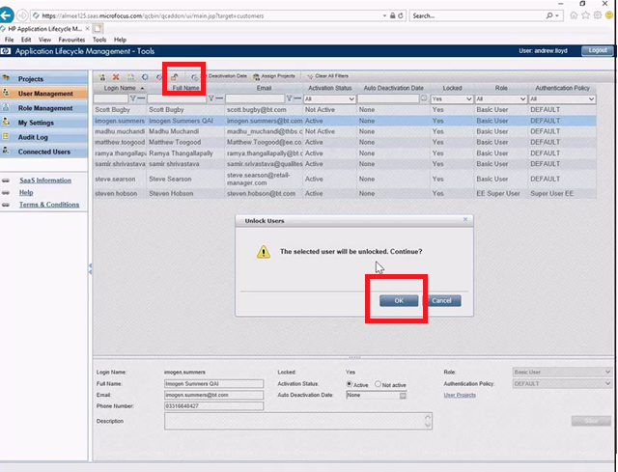

## Robotic Process Summary

The Entire scope of robot process in QC administration will fall within (User Creation, Reactivation, Roles assignment) based on the request raised by requestor in SharePoint. Robot

Will pick the requirement from mailbox and successfully create in QC tool and generate an email to requestor on request complete status.

## Scope of the Automation

The Entire scope of automation of QC administration will fall within (User Creation, unlock account, Reactivation, Roles assignment) based on the request raised by requestor in SharePoint.

## Process Volume & Profile

The benefits were analysed with the team on the number of hours they spend over the processes.

## Compliance & Regulation

## Risks & Mitigation

[In this section describe the risks of automating the process as well as those of not automating the process. Complete the table below, add/remove rows as required.]

| **Description of Risk** | **Impact of Not Addressing the Risk** | **Mitigation** |
| --- | --- | --- |
|  |  |  |
|  |  |  |
|  |  |  |

# Operational Impact

## Impact to Existing Processes

The existing human process will be engaged by robot for sending the notification and creating user profile to the users who have given the request for QC tool, this will save the human efforts in hours.

## Impact to Training

N/A

## Impact to Existing Systems

There is no impact to existing system as automation is not replacing any system.

# Robotic Process Detail

## Triggering the Robotic Process

The Robot process Starts when email is triggered from SharePoint to Robot mailbox.

## Work Item Priority

The work Item is prioritized based on the incoming request which is approved.

## Robotic Flow

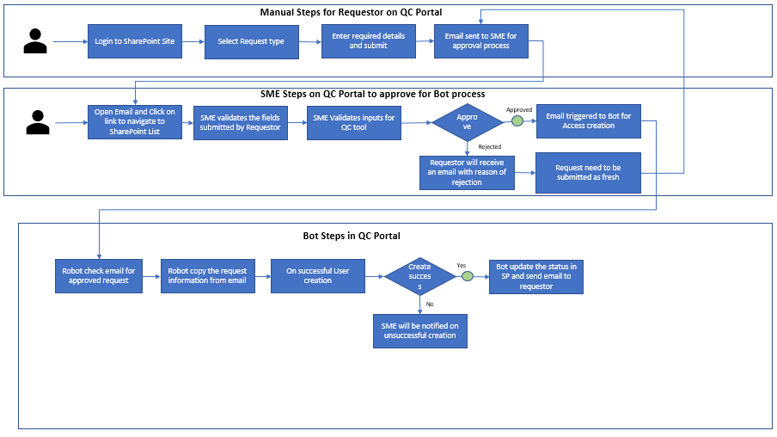

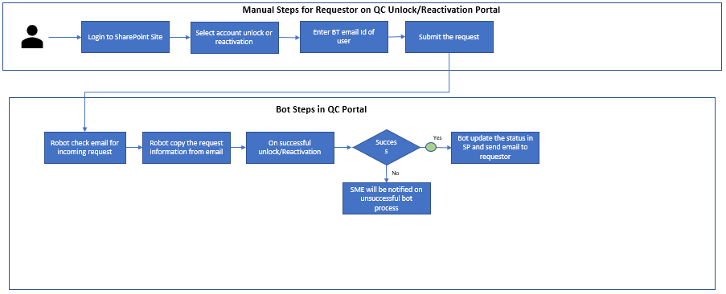

## Robotic Flow

1. Robotic Flow User/Access Creation

* Robot starts to monitor the functional mailbox for input email from SharePoint portal for creation request based on the subject line.
* The Robot copy the information such as (Full Name for user, Access type, BT Email Address)
* The Robot Login into QC tool and Navigate to Admin page by providing crendetials
* Robot Click on User management
* Robot Click ADD User
* Robot enter the Login Name and Email ID and the Domain should be authorized
* Robot Create a password
* Robot to Click Send Notification
* Robot to Click OK button
* Robot Assign project for user new user
* Robot Highlight the new user and click Assign Projects
* Robot select domain Name, Project Name
* Robot grant and remove roles for the selected users in the selected project by checking and unchecking the relevant checkboxes.
* Robot clicks next which takes to summary Page
* After clicking finish button, status will be displayed as operation completed
* Requestor will be sent email on succussfull creation of user from SP when robot update the status back in SharePoint

1. Robotic Flow Roles and Project Allocation

* Robot to Click the user and Assign project
* Robot select Domain Name, Project Name
* Robot grant and remove roles for the selected users in the selected project by checking and unchecking the relevant checkboxes.
* Robot Click Next which takes to Summary page and click finish
* Robot Send the notification email to the user that Additional access has been granted

1. Robotic Flow Reactivation/Unlock Account

* Robot receive the request in mailbox for reactivation request
* Robot login to QC tool
* Robot copy login name and enter in QC tool
* Robot click the activation status to active and click save
* Robot Send email notification to the notification to login into QC portal

1. Robotic Flow Unlock Account

* Robot receive the request in mailbox for unlock request
* Robot login to QC tool
* Robot click the unlock user icon to activate the locked account and click OK
* Send email to requestor on successful unlock

# Process Layer

## Process Detail

Offices worldwide

© British Telecommunications plc 2014

Registered office: 81 Newgate Street, London EC1A 7AJ

Registered in England No: 1800000



# Object Layer

This section describes the components in the Blue Prism object layer that interact with the systems and applications used by the process. This includes the list of systems that will be accessed by the automation as well as other objects that perform specific functions as part of the automation. Web services will be used wherever available as this increases reliability of the automation while reducing both complexity and resource usage of the target application.

The application and function objects are described in the following sections.

[In this section, you will outline the major application and functional objects that are part of your Blue Prism solution. Describe what each object will do and the primary inputs and outputs. Remember that you will have at least one object for each application in your solution. If ready-made objects will simply be called and not created, then be sure to detail that. It is only necessary to include details of Blue Prism built in objects where they have a major function within your solution.]

## [Name of Object]

[Starting with this section, describe each application and functional object. Depending upon solution, there will be a variable number of these sections and there could be many. Ensure that you make it clear if the object will call a web service or API.]

# Data Model

## Data Structure Principles

This automation will pass data between processes and objects using data collections rather than individual data items where possible.

Though several data collections are used repeatedly throughout the automation, they will be passed between processes and objects each time that they are required. Globally visible data collections will not be used to ensure data isolation for troubleshooting.

[The purpose of this chapter is to outline the major data elements that you will solution. Collections should be used where appropriate and while Blue Prism permits use of global variables (data items that are visible outside their original page), this functionality will not be used. Collection definitions should be created at run-time with only the very first instance having individual fields defined.]

## Primary Data Structures

While numerous local and interim data structures are used for individual processes and objects, the following primary data collections will be used throughout the automation:

[In this section list the major data items that you will use. This can be in the form of a table or a bulletted list as appropriate for your design. For your major collections, describe the fields that will be in each collection.]

[Call out in this section any customer or confidential data that will be handled by your process.]

## Data Types

All data, including numbers, will be held as ‘Text’ with the exception of flags (Booleans), dates and passwords. This ensures the widest possible compatibility between systems.

## Environment Variables

The following variable will be defined across the automation. This approach is used to make modification of global values straightforward by not coding them into the solution.

[Environment variables should be used to avoid hard-coding constants into your solution. In this section describe the environment variables that you will create and use in your solution.]

## Data Storage

[In this section describe what information will be stored by the automation in Blue Prism. Describe where that data will be stored and why. Highlight any customer or confidential data.]

# Exception Handling

It is inevitable that the robot will encounter that prohibit either processing of a single work item or prevent all further processing. These situations are known as exceptions and the Blue Prism solution will be developed to handle as many exceptions as possible.

## System Exceptions

System exceptions indicate where the robot has issues with interfacing a given system. This can be due to unavailability of a target system, latency in that target system or indicative of a change to the target system.

[In this section, describe how system exceptions will be handled. Typically, the robot will retry up to three times, before taking action. Specifiy the number of retries and what action the robot will take if unsuccessful.]

## Business Exceptions

A business exception is a situation where the robot does not have the logic defined in order to progress or a valid business rule failure has occurred.

[In this section describe how the robot will handle business exceptions.]

## Other Handoffs

[In this section describe any additional hand-offs between the robot and human operators. If there are no hand-offs, indicate so in this section.]

# Design, Configuration & Testing

## Design, Configuration and Testing Principles

Robotic automations are designed and configured by an RPA Analyst from Intelligent Automation. For large projects, a lead analyst will be supported by one or more additional analysts. The lead analyst being accountable for the end to end design and configuration of the automation, while the other analysts will take responsibility for configuring one or more process elements.

Automation configuration is completed on a dedicated development virtual machine that is not used for production automations. In order to complete the design and initial configuration of the automation, the RPA analyst(s) will request access to the required systems using their own credentials. This ensures full traceability and auditability during the design and configuration process.

The design process involves reviewing the end to end human process and mapping the human process elements to robotic process elements. During this activity, the RPA analyst will access the systems involved in the process (using their own user accounts) to understand the process steps and the data required for each step.

The configuration stage requires building the design into Blue Prism. This includes creating the object layers to interact with the systems involved in the process and building the process layers that contain the logic and steps required to complete the process by directing the object layers to take the necessary actions. During the configuration stage, the RPA analyst will capture elements of the screens of the involved systems (using their own user accounts) to teach Blue Prism how to access the systems.

During configuration, individual process elements will be tested in isolation. This testing will not commit any changes to the involved systems, but will be undertaken by inputting values directly into Blue Prism variables to exercise the process logic and data flow.

Once configuration is complete, early end to end testing will be undertaken, using the RPA analysts own user accounts and simulated data, to validate that the robotic process moves correctly between process elements. Subject matter experts will be involved at this stage to provide validation and support as any amendments are configured and tested.

The final stage of testing is undertaken using the robot’s user accounts and either simulated data or ring-fenced live data. This testing is undertaken in the presence of subject matter experts to ensure that any changes committed as part of the testing are valid and can be reversed if necessary.

After live launch, robotic operation will be throttled to ensure only a slow flow of live transactions through the robotic process with ongoing validation by the RPA analyst and subject matter experts. Only when all parties are confident that that robotic automation is working as designed will traffic be increased and the robot ramped up to full production volumes.

A test plan document will be issued for stakeholder approval.

## Warranty Period

For a period of not less than seven (7) calendar days, robotic automations will benefit from active warranty support. During this period, robotic processes will be monitored closely by the RPA analyst and subject matter experts, which any issues addressed and retested quickly. The warranty period will be brought to a close only when all parties are confident that that automation is operating as designed and processing the required volume of transactions.

## Environments

Automation design, configuration and initial testing take place using dedicated development virtual machines. Following successful initial end to end testing, the automation will be loaded onto a single production virtual machine for further testing and launch. After live launch, the robotic process may be executed from additional virtual machines if this is required by the process volumes.

All design, configuration and testing is completed against live involved systems. This is a low risk activity as all access is controlled by existing user control measures, auditing and accountability. In addition, only production systems behave as required to deliver the end to end process.

Test environments may be accessed if available though only where the owners of those test environments can confirm that they function and behave in a manner identical to live systems. Automation configuration requires capture of specific interface components to that Blue Prism may access involved systems correctly. Where test systems differ, even if they appear to be identical visually, automation configuration is not representative or reliable. For this reason, all automation design and configuration will be undertaken on production systems and test systems used only by exception.

# Reporting

Data will be captured from Blue Prism to support analysis of the automation for the following purposes:

* Tracking of benefits;
* Resource utilisation of the robotic virtual machines;
* Identification of common failure points;
* Identification of system or process changes impacting the automation;
* Monitoring of transaction volume and success rate;
* Identification of training issues regarding hands off between robots and human Order Managers.

In order to support this report, the automation will tag the Blue Prism queue with details of the stages of the automation completed. This will provide a granular view of the automation making issue identification possible.

## Tagging

In order to track progress of the automation and identify the steps completed, the automation will apply tags to the Blue Prism queue item at multiple points during processing.

The tags applied during automated processing will be as detailed in the following tables. A space is added at the end of each tag to ensure that multiple tags are easy to read.

[In this section detail the tags that will be applied to Blue Prism queue items. This information is best presented in a table format as shown below – add rows as required. Tags should be numbered in a sensible manner so that they appear in a logical sequence that matchs your process flow.]

[Your tags should include process variables where appropriate to improve reporting and troubleshooting, such as reference numbers. However, you should not include customer or confidential information unless essential for your process.]

| **Process Tags** | |
| --- | --- |
| **Action** | **Tag Applied to Blue Prism Queue Item** |
| Example | "101 – Tag description. " |
| Example | "102 – Tag description. " |

# Robotic Workforce & Scheduling

## Working and Non-Working Days

[In this section describe the days when the robot will and the days when it will not. Be clear about whether or not the robot will work on bank or public holidays.]

## Robotic Workforce

Each robot has a unique EIN and is a virtual employee of BT. The following robotic users may be engaged for this automation.

[In the table below, list the robotic EIN’s that will run the process. Add/remove rows as required.]

| **Robot User** | **Robot EIN** |
| --- | --- |
| [Robot User] | [Robot EIN] |
| [Robot User] | [Robot EIN] |

## Robotic Process Schedule

The robot will be operating according to the following schedule.

[In the table below, describe the schedule that will be built into Blue Prism. List this for each robot that will run the process and the names of the processes that each robot will run. Add/remove rows as required.]

| **Robot VM** | **Robot User** | **Process** | **Start Time** | **Finish Time** |
| --- | --- | --- | --- | --- |
| [VM Name] | [Robot User] | [Name of Process] | [Time] | [Time] |
| [VM Name] | [Robot User] | [Name of Process] | [Time] | [Time] |

[Remove the following line if it does not apply to your solution.]

These VM’s are located in two different BT data centres to deliver resilience in case of a failure at one data centre.

# In Life Management & Support

## Change Management

Automations work by interacting with the same user interface as is accessed by human operators. Therefore, automations can be impacted by changes to that interface, including those that change the functionality even if not the appearance of the interface. For continued successful operation of automated processes, Intelligent Automation will engage with the same change notification mechanisms as other system users. This will provide early notification of upcoming changes so that automations can be modified if required. The worst-case scenario is that the Intelligent Automatoin team will break-fix automations when reporting and monitoring highlight failures of automated processing which is then analysed to be due to a change to application interfaces.

## Support Framework

Automations built by Intelligent Automation will be supported in-life by the team. It is important to note that support of the applications used by a process and the virtual machines on which the automated processes run will be undertaken by the teams responsible for those elements. Intelligent Automation operate support with the following principles:

* All automated processes to have human contingency, where items can be actioned manually by the operation in the event of failure of an automation.
* All automations to be configured with recovering logic that will endeavour to restart or resume from failures.
* All automations to be configured with an alerting mechanism (for example, email to a shared mailbox) to notify the team of failures.
* Out of hours support restricted to restart and recovery only – more extensive fixes to be actioned from the next working day.

## Reporting & Monitoring

Automated processes are configured to include monitoring and reporting across the process flow elements. This is for audit purposes and to monitor automated processes for issues and failures.

# Access Control

## Principles of Robotic Access Control

Robotic operators are subject to the same access controls as human operators. Robots require no additional system access rights or privileges beyond those assigned to human operators completing the same processes. In fact, as robotic operators will typically work on only one process, their access right may be configured more precisely and restrictively than standard human user accounts.

Robotic operators have unique EIN’s and will access the systems used by processes using unique access accounts. These accounts will be subject to the same restrictions, auditing and rules as human operator accounts.

## Access Accountability

Prior to releasing a robotic automation to live operation, the end to end process flow is tested, reviewed and validated. This validation includes review by the process owner and subject matter expert(s). This review ensures that the robotic operator is completing the process in a manner consistent with policies and analogous to how the process is completed by human operators, though not necessarily in the same sequence. Only once all stakeholders are confident that the robotic process has been configured correctly will it be used with live data.

Robot accounts are owned and managed by the business unit for which the automation has been built. The Intelligent Automation team does not own or manage these accounts. The business unit will appoint a responsible line manager for the accounts and will manage them in the same way as for accounts belonging to human users that they manage.

## Access Management

Robotic user accounts are subject to the same management controls as similarly configured human user accounts. This management may include routine password updates or regular validation of the requirements for access. Any required updates or account maintenance will be managed by Intelligent Automation as part of the regular in-life management of robotics.

# Glossary

|  |  |
| --- | --- |
| **Acronym or Term** | **Definition** |
| BAU | Business as Usual |
| DC | Data Collection |
| FTE | Full Time Equivalent |
| RPA | Robotic Process Automation |
| SME | Subject Matter Expert |
| VM | Virtual Machine |

[Add/remove rows as required.]

Offices worldwide

© British Telecommunications plc 2014

Registered office: 81 Newgate Street, London EC1A 7AJ

Registered in England No: 1800000

